**2. Draw a graph and decide the coefficient c**

First, we drew a graph with the result we gained by using Strassen_Algorithms with threshold that we found.

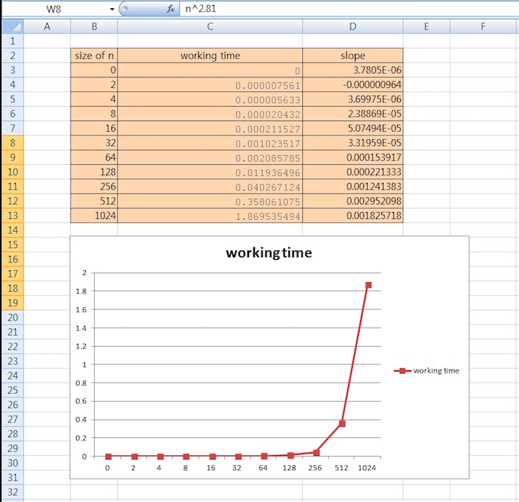

*Figure 1

We used size of n as x-axis and working time as y-axis.

After that, drew the graph about “c * n^2.81” when c is from 1 to 10.

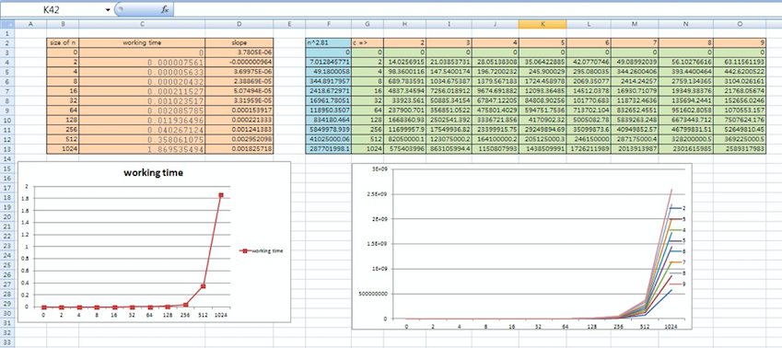

*Figure 2 *(when c is 1 to 10)*

When we compare working time graph and value of c*n^2.81’s graph, we found that both graphs are similar when c’s value is 8 or 9.

So, we decided to check more detail, and drew a graph when c’s value is ranging from 8.0 to 8.9.

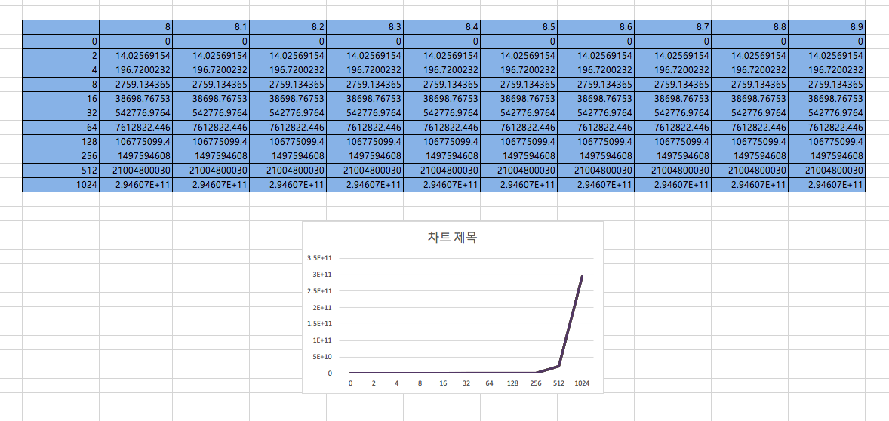

*Figure 3 *(when c is ranging from 8.0 to 8.9)*

But, all values were similar, we can’t see difference of graphs ranging from 8.0 to 8.9.

So, we decided to designate value of c between 8 and 9.

This is a graph when c is 8 and 9.

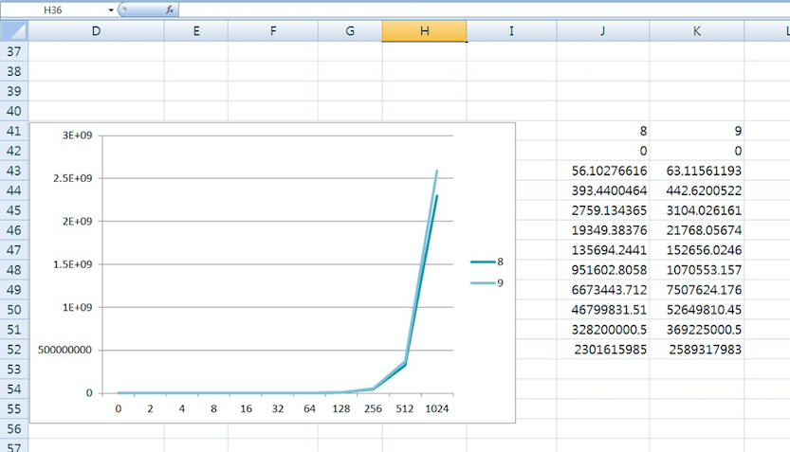

*Figure 4 *(when c is 8 or 9)*

When we compare working time graph and above graph, we can find that it is much similar when c is 9.

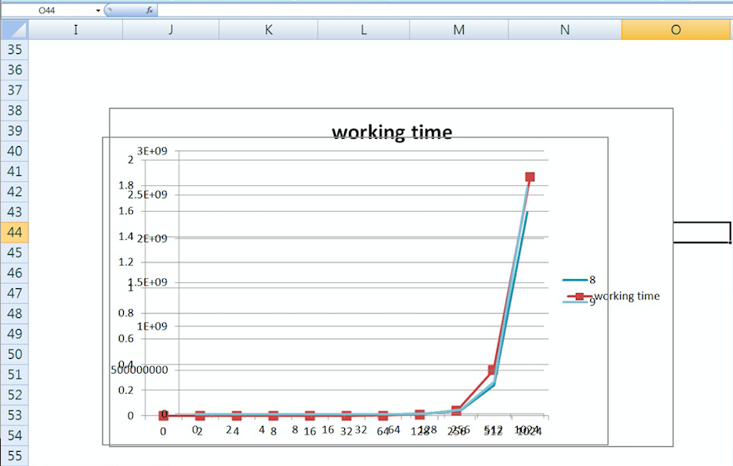

*Figure 5 *(compare both graph)*

Based on the above information, we conclude that c = 9.